**Case Study: Advantages of Using AI in Government and Public Sector**

**Oluchi Obinna**

**6252-ITAI-2372-Artificial Intel Applications**

### 

### 

### 

### 

### 

### 

### 

### 

### 

### 

### 

### 

### 

### 

### 

### 

### **Case Study: Advantages of Using AI in Government and Public Sector**

### **Introduction**

Artificial Intelligence (AI) is a branch of computer science that aids machines in performing tasks that typically require human intelligence using higher computing power (GPU). It aims to aid and advance, which is why In recent years, AI has been increasingly adopted by governments and public sector organizations to improve their efficiency, decision-making, and service delivery. From things such as traffic management to healthcare, AI technologies have been, and continue to transform how public services are provided, making them much more responsive and effective.

### **AI in Fraud Detection – Canada’s Revenue Agency**

**Problem or Need Addressed**

The Canada Revenue Agency (CRA) has a Criminal Investigations Program (CIP) that works to detect and stop serious tax crimes. Some of the biggest cases they investigate involve tax evasion with international connections. These cases often include people hiding money in other countries to avoid paying taxes in Canada. There are also promoters and tax preparers who create complicated and organized tax schemes to help others cheat the system. These schemes may include things like fake business expenses, filing two sets of books, or claiming personal purchases as business expenses. In some cases, these crimes are linked to money laundering, which is when illegal money is made to look like it comes from legal sources. Because these crimes can cross borders and involve other illegal activities, the CRA often works with other law enforcement agencies in Canada and internationally. Their goal is to protect taxpayer money and make sure that everyone follows the law.

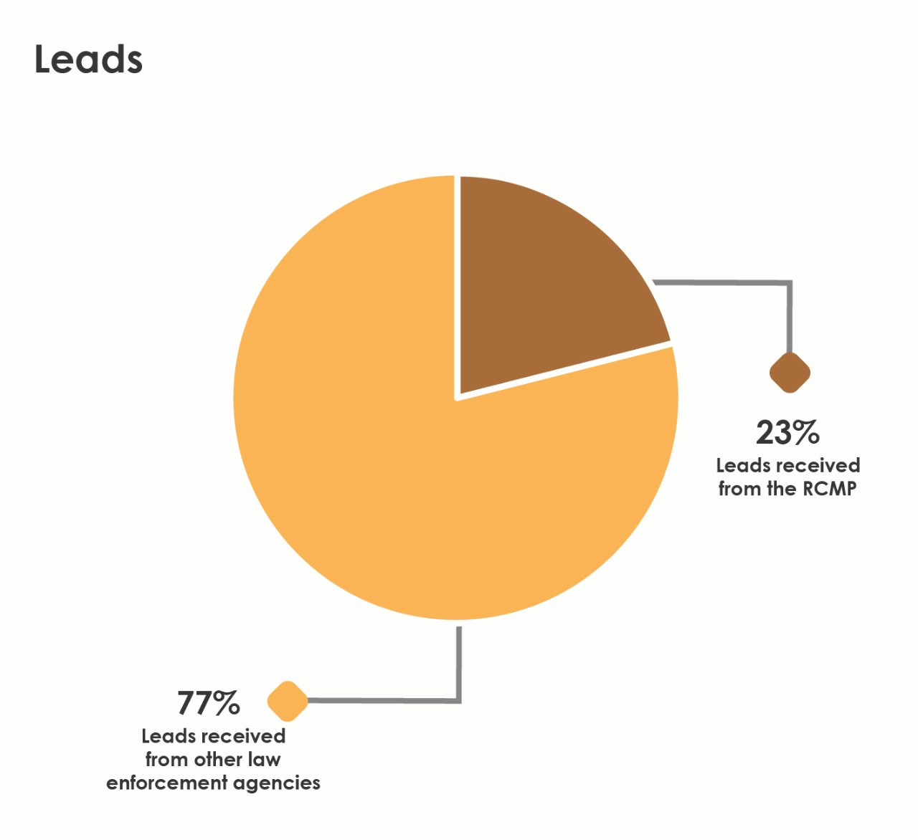

In addition to international tax crimes, the CRA also investigates local tax offences that impact the country's financial stability. These include people not filing their tax returns or underreporting their income, which is an offence that can lead to huge fines and even jail time. Another serious problem is false claims for government benefits, credits, and tax refunds. Some people lie on their tax forms to receive money they don’t deserve, which is unfair to those who actually need help. The CRA has experts in areas like digital forensics and criminal intelligence who support these investigations. They also receive tips from within the CRA or from outside partners, which help them start new cases. All these efforts are important because they help maintain fairness in the tax system and ensure that Canadians trust their government to use public funds responsibly. To address this problem, the CRA implemented AI-driven fraud detection systems that analyze financial transactions, cross-reference tax filings with other records, and use machine learning algorithms to identify patterns indicative of tax evasion.

**Outcomes and Benefits Achieved**

* Recovery of approximately CAD 500 million in unpaid taxes within the first year.
* Faster fraud investigations through automated insights.
* Enhanced efficiency in audits, reducing the workload on human auditors.

**Challenges or Limitations Observed**

* Concerns over data privacy and ethical use of AI in analyzing personal financial information.
* Need for continuous monitoring to prevent algorithmic biases.
* Ensuring transparency and maintaining public trust in AI-driven processes.

### **AI for Mental Health and Crisis Intervention in Public Health**

**Specific Issue in Governance**

During the first year of the COVID-19 pandemic, there was a major increase of about 25% in the number of people worldwide dealing with anxiety and depression. This was mainly caused by high levels of stress due to social isolation and fear. Many people were unable to go to work, see their friends or family, or take part in community activities. Loneliness and the fear of getting sick or losing loved ones added to the emotional pressure. Health workers, in particular, were extremely overwhelmed, and some even began to think about suicide because of how exhausted and emotionally drained they were. Young people and women were among the groups most affected, and those with existing health problems like asthma or cancer were also more likely to suffer from mental health issues during this time.

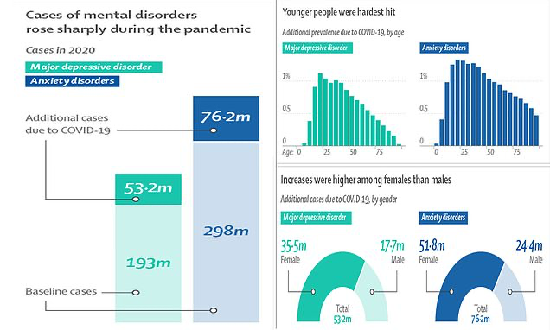

Unfortunately, while more people needed mental health support, many mental health services were shut down or harder to access because of the pandemic. This made it difficult for those with serious conditions to get the help they needed, whether it was for anxiety, depression, or substance use. Even though some support was added to national COVID-19 response plans, most countries still had big gaps in providing care. As a result, many people had to look for help online, showing that digital mental health tools are now more important than ever. But in poorer areas or countries with fewer resources, creating and using these digital tools is still a major challenge. This situation shows that the world needs to pay more attention to mental health, especially during global emergencies.

Public health systems in many countries have a hard time giving people the mental health support they need. One big reason is that there aren’t enough trained mental health professionals or services to meet the growing demand. Hospitals and clinics are often already stretched thin with physical health problems, leaving less attention for mental health. In some places, especially rural or low-income areas, there may not be any mental health centers at all. Another issue is stigma- many people are afraid or embarrassed to talk about their mental health because they think others will judge them. This can stop them from asking for help until things get really bad. That’s why early detection and intervention are so important. If mental health issues like anxiety, depression, or stress can be spotted early, people can get help before it turns into a crisis. Early support might include counseling, therapy, or even just someone to talk to who understands. This not only helps the individual feel better but also reduces the pressure on doctors, hospitals, and emergency services. Investing in early mental health care is like fixing a small leak before it floods the whole house- it saves time, money, and lives in the long run.

**Proposed AI Application**

One way to improve mental health support is by using AI-powered chatbots and voice analysis tools. These tools can be added to public health systems to help spot the early signs of mental health problems like anxiety, depression, or emotional distress. AI chatbots can talk to people online or through apps and offer them a safe, private space to share how they’re feeling. Since these bots are available 24/7, people can get help anytime, even when mental health professionals aren’t available. This can be really helpful for those who may feel too embarrassed or scared to talk to a real person right away. AI tools can also track changes in the way someone speaks or writes to detect signs that they might be struggling emotionally.

These AI systems don’t replace doctors or therapists, but they work alongside them to make mental health care faster and more efficient. For example, if the AI detects that someone is showing warning signs of a mental health crisis like suicidal thoughts, it can alert health professionals so they can step in quickly. This helps catch problems early, before they turn into serious emergencies. It also gives doctors more information to help them understand what the person is going through. By using AI in this way, public health systems can reach more people, especially in places where mental health care is hard to access. It’s a smart and modern solution to a growing problem, but it also needs to be used carefully to protect people’s privacy and emotions.

**Justification and Expected Outcomes**

* **24/7 Accessibility:** AI chatbots can offer round-the-clock support, providing users with immediate assistance regardless of time or location.
* **Anonymity and Reduced Stigma:** Users may feel more comfortable discussing sensitive issues with AI tools, encouraging more people to seek help.
* **Early Detection:** Voice analysis tools can identify subtle changes in speech patterns that may indicate mental health issues, allowing for early intervention.
* **Resource Optimization:** By handling initial assessments, AI tools can reduce the workload on healthcare professionals, allowing them to focus on their more severe cases.

**Potential Challenges**

* **Data Privacy:** Ensuring the confidentiality and security of sensitive user data is paramount.
* **Accuracy and Reliability:** AI tools must be rigorously tested to ensure they provide accurate assessments and do not miss critical signs of distress.
* **Ethical Considerations:** The use of AI in mental health may raise ethical questions about the replacement of human interaction and the potential for misuse of data.

### **Conclusion**

Using Artificial Intelligence (AI) in government services has already shown great success, like how the Canada Revenue Agency (CRA) uses it to find fraud more quickly and accurately. This shows that AI can help public systems work better by doing tasks faster and spotting problems that humans might miss. If we take that same idea and apply it to mental health, AI could help a lot of people by giving them support right when they need it. AI tools like chatbots can talk to people who are struggling with their emotions and help them feel less alone. These tools can also look for signs of serious issues before things get worse, which means people can get help sooner.

Although this works, it must be really carefully applied. Mental health is personal and sensitive, so it’s important to make sure people’s private information is protected. There’s also the concern that AI might not always understand how someone feels the same way a human can, especially when emotions are complex. So, the technology has to be tested carefully to make sure it’s reliable and helpful. Governments and health workers must set clear rules on how the AI is used, so it supports people in the right way without replacing the human touch that is still so important in mental health care. With the right balance, AI can be a powerful tool for improving mental health support in public health systems.

### 

### 

### 

### 

### 

### **References**

1. <https://blog.govnet.co.uk/technology/ai-in-government-case-studies>
2. <https://www.hcltech.com/trends-and-insights/top-ai-applications-government-contributing-public-sector-innovation>
3. <https://emerj.com/ai-government-current-ai-projects-public-sector/>
4. [*https://www.canada.ca/en/revenue-agency/programs/about-canada-revenue-agency-cra/compliance/criminal-investigations-canada-revenue-agency.html#toc5*](https://www.canada.ca/en/revenue-agency/programs/about-canada-revenue-agency-cra/compliance/criminal-investigations-canada-revenue-agency.html#toc5)
5. [*636 × 382*](https://www.dailymail.co.uk/health/article-10074211/Cases-depression-anxiety-rose-25-worldwide-COVID-19-pandemic.html)
6. [*https://www.who.int/news/item/02-03-2022-covid-19-pandemic-triggers-25-increase-in-prevalence-of-anxiety-and-depression-worldwide#:~:text=In%20the%20first%20year%20of,Health%20Organization%20(WHO)%20today.*](https://www.who.int/news/item/02-03-2022-covid-19-pandemic-triggers-25-increase-in-prevalence-of-anxiety-and-depression-worldwide#:~:text=In%20the%20first%20year%20of,Health%20Organization%20(WHO)%20today.)